CO1-Assesment Tool -1

Course: Computer Architecture Name: Siva Balan K
Course Code: CSA1203 Reg.no: 192572037
ANNEXURE A – APPLICATION-BASED QUESTIONS

1. SMART CITY SURVEILLANCE SYSTEM: CPU, MEMORY, I/O AND BUS STRUCTURE

Problem Understanding:

A smart city surveillance system receives continuous video streams from many cameras. The video data must move from the cameras to I/O controllers, then to memory and finally to the CPU for processing. During peak hours, several cameras transfer large amounts of data simultaneously. This creates delays in data transfer and threat detection.

Application of Concepts:

The CPU performs video analysis and executes threat-detection instructions. Memory temporarily stores video frames and program data. I/O devices transfer camera feeds into the computing system.

The system may experience lag due to:

1. Slow I/O transfer from cameras
2. Limited memory bandwidth
3. CPU waiting for video data
4. Multiple devices competing for the same bus
5. Cache misses and repeated memory access
6. A large number of instructions required for video processing

Single-Bus Structure:

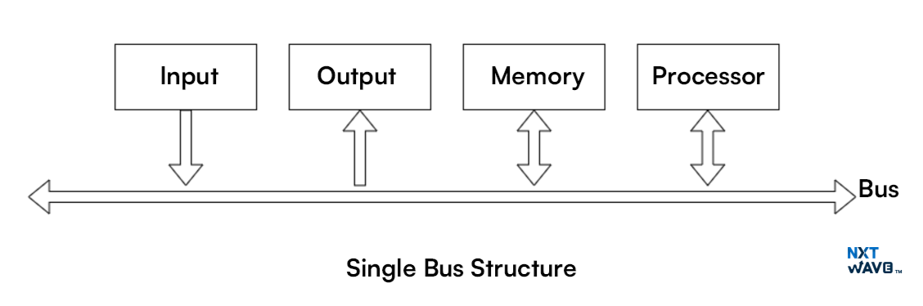
In a single-bus system, the CPU, memory and I/O devices share one common communication path.

Advantages:
- Simple design
- Low hardware cost
- Easy to control

Disadvantages:
- Only one data transfer can occur at a time
- CPU, memory and cameras compete for the same bus
- Bus congestion occurs during peak hours
- Overall performance becomes slow

For example, while one camera transfers a frame to memory, another camera may have to wait.

Multi-Bus Structure:

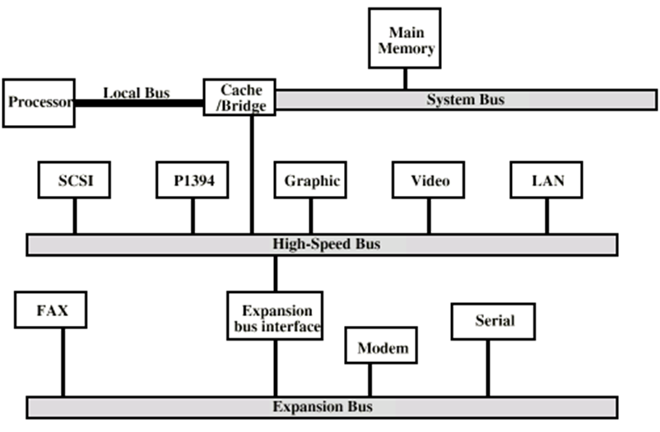
A multi-bus system uses separate buses for different operations.

For example:
- Memory bus between CPU and memory
- I/O bus for camera devices
- High-speed internal processor bus

Advantages:
- Multiple transfers can take place simultaneously
- Reduces competition between CPU, memory and I/O
- Improves memory and I/O bandwidth
- Suitable for high-volume video systems

A multi-bus structure is more suitable for the surveillance system because camera input and CPU-memory communication can occur in parallel.

Improving the Instruction Execution Cycle:

The processor normally performs:

Fetch → Decode → Execute → Store Result

Performance can be improved using:

- Pipelining to overlap instruction stages
- Cache memory to reduce main-memory access
- Direct Memory Access to transfer camera data without continuous CPU control
- Multiple CPU cores for processing different camera streams
- Larger data buses to transfer more bits at a time
- Faster memory and I/O controllers
- Branch prediction to reduce pipeline delays

Problem-Solving Approach:

1. Use DMA for transferring video frames from cameras to memory.
2. Use a multi-bus structure to separate I/O and memory traffic.
3. Store frequently used instructions and frames in cache.
4. Process different camera feeds using multiple cores.
5. Use pipelining to execute several instructions simultaneously.

Result and Justification:

The main cause of lag is the high volume of data moving through shared system resources. A single bus becomes a bottleneck because all devices compete for it. A multi-bus architecture, DMA, cache memory, pipelining and parallel processing improve data transfer and instruction execution. Therefore, threat detection becomes faster and more reliable.

2. STOCK TRADING APPLICATION: INSTRUCTION CYCLE AND CPI REDUCTION

Problem Understanding:

A stock trading application executes millions of instructions per second. During high load, many transactions, market updates and calculations are processed at the same time. Frequent memory access and branch instructions increase the Cycles Per Instruction, causing transaction delays.

Application of Concepts:

The execution time of a program is represented as:

CPU Execution Time =
Instruction Count × CPI × Clock Cycle Time

CPI means the average number of clock cycles required to execute one instruction.

The processor follows the fetch–decode–execute cycle:

1. Fetch:
The CPU obtains the instruction from memory.

2. Decode:
The control unit determines the operation and operands.

3. Execute:
The ALU or another execution unit performs the operation.

4. Memory Access:
Data may be read from or written to memory.

5. Write Back:
The result is stored in a register or memory.

Causes of High CPI:

- Cache misses during frequent memory access
- Slow main memory
- Incorrect branch prediction
- Pipeline stalls
- Data dependency between instructions
- Limited execution units
- Repeated movement of data between memory and CPU

Branch instructions are common in stock applications because the program continuously checks prices, limits, transaction conditions and risks. Incorrect branch prediction clears the pipeline and increases CPI.

Architectural Improvements:

1. Cache Memory:

Frequently used market values and instructions should be stored in L1, L2 and L3 cache. Cache access is faster than main-memory access.

2. Pipelining:

Pipelining overlaps instruction stages. While one instruction is executed, another can be decoded and another fetched.

3. Branch Prediction:

The CPU predicts whether a branch will be taken. Accurate prediction prevents pipeline flushing and reduces delay.

4. Out-of-Order Execution:

Independent instructions can be executed before an earlier instruction that is waiting for data.

5. Register Usage:

Frequently used values should be kept in CPU registers instead of repeatedly accessing memory.

6. Prefetching:

The processor can load expected instructions and data into cache before they are required.

7. Multiple Cores:

Transaction validation, market-data processing and user requests can be executed on different cores.

Problem-Solving Approach:

1. Identify instructions causing frequent cache misses.
2. Improve data locality and cache usage.
3. reduce unnecessary memory operations.
4. Use branch prediction and conditional instructions.
5. execute independent tasks on multiple cores.
6. Optimize software to reduce the total instruction count.

Result and Justification:

Transaction delay occurs because high CPI increases CPU execution time. Cache memory, pipelining, branch prediction, prefetching, multiple cores and efficient register usage reduce stalls and memory delays. Therefore, the processor can complete more transactions per second with lower response time.

3. ADDRESSING MODES AND INSTRUCTION SET OF 8085

Problem Understanding:

An 8085-based temperature control system reads sensor values and controls actuators such as fans, alarms or cooling devices. Incorrect readings may be processed when the program uses the wrong addressing mode or accesses an incorrect memory location.

Addressing Modes of 8085:

1. Immediate Addressing:

The data is directly included in the instruction.

Example:

MVI A, 32H

Here, 32H is directly loaded into the accumulator.

2. Register Addressing:

The data is stored in a CPU register.

Example:

MOV A, B

The content of register B is copied into register A.

3. Direct Addressing:

The memory address is directly specified in the instruction.

Example:

LDA 2500H

The data stored at memory location 2500H is loaded into the accumulator.

4. Register Indirect Addressing:

The memory address is stored in a register pair.

Example:

MOV A, M

Here, the HL register pair contains the address of the data.

5. Implied Addressing:

The operand is understood from the instruction itself.

Example:

CMA

This instruction complements the accumulator.

Possible Causes of Incorrect Temperature Readings:

- HL register pair contains the wrong memory address
- Direct address points to an unrelated memory location
- Immediate data is mistaken for an address
- Sensor input port is incorrectly selected
- Previous data remains in the accumulator
- Incorrect scaling or comparison value is used
- Registers are modified before the sensor value is processed
- Interrupts change register values without saving them

Effective Use of the 8085 Instruction Set:

Sensor input can be read using:

IN port-address

The received value can be compared with a temperature limit using:

CPI data

Conditional jump instructions can then control the actuator:

JC address
JZ address
JNC address

The actuator can be controlled using:

OUT port-address

Example Logic:

READ sensor value
COMPARE it with maximum temperature
IF temperature is high
Turn ON cooling device
ELSE
Keep cooling device OFF

Pseudocode:

BEGIN
Configure sensor and actuator ports

REPEAT
Read sensor value using IN instruction
Store the value in a safe register or memory
Compare value with temperature limit

IF value is greater than or equal to limit THEN
Send ON signal to actuator
ELSE
Send OFF signal to actuator
END IF
FOREVER
END

Reliability Improvements:

- Initialize all registers before use
- Load the correct address into HL
- Preserve registers during interrupts
- Validate sensor values
- Use correct input and output ports
- Store temporary readings in known memory locations
- Add repeated sampling to avoid noisy readings

Result and Justification:

Addressing modes determine where the processor obtains its operands. An incorrect addressing mode may cause the CPU to read a constant, register or memory location instead of the actual sensor value. Correct use of IN, OUT, MOV, LDA, STA, CPI and conditional jump instructions ensures accurate and reliable temperature control.

4. SEGMENTED MEMORY AND ADDRESSING IN 8086

Problem Understanding:

The 8086 microprocessor uses segmented memory to access up to 1 MB of memory. Programs may experience incorrect data access or stack overflow when segment registers and offsets are not initialized or managed correctly.

Application of Segmentation:

The 8086 divides memory into logical segments.

1. Code Segment:

The Code Segment register, CS, stores the base address of program instructions.

The Instruction Pointer, IP, contains the offset of the next instruction.

Instruction address is represented as:

CS:IP

2. Data Segment:

The Data Segment register, DS, stores the base address of program data.

Most data instructions use DS with an offset.

3. Stack Segment:

The Stack Segment register, SS, stores the base address of the stack.

The Stack Pointer, SP, points to the top of the stack.

Stack address is represented as:

SS:SP

4. Extra Segment:

The Extra Segment register, ES, is mainly used for additional data and string operations.

Physical Address Calculation:

Physical Address =
Segment Address × 10H + Offset Address

For example:

Segment = 2000H
Offset = 1200H

Physical address:

2000H × 10H + 1200H
= 20000H + 1200H
= 21200H

Causes of Incorrect Data Access:

- DS is not initialized correctly
- Wrong offset is used
- Incorrect segment override is applied
- Data is stored outside the assigned segment
- Code accidentally accesses the stack segment
- Segment registers are changed without restoring them

Causes of Stack Overflow:

- Stack size is too small
- Too many PUSH instructions are used
- POP instructions do not match PUSH instructions
- Recursive procedures do not terminate
- SP is initialized incorrectly
- Procedure calls are made without proper returns

Instruction Execution:

The processor fetches instructions using CS:IP. Data is normally accessed through DS. Stack operations such as PUSH, POP, CALL and RET use SS:SP.

During instruction execution:

1. Instruction is fetched from CS:IP.
2. It is decoded by the control unit.
3. Operand address is calculated.
4. Data is obtained from a register or memory.
5. The operation is executed.
6. The result and flags are updated.

Addressing Modes:

8086 supports:

- Immediate addressing
- Register addressing
- Direct addressing
- Register indirect addressing
- Based addressing
- Indexed addressing
- Based-indexed addressing

For example:

MOV AX, 1234H Immediate
MOV AX, BX Register
MOV AX, [2500H] Direct
MOV AX, [BX] Register indirect
MOV AX, [BX+SI] Based-indexed

Problem-Solving Approach:

- Initialize DS using the correct data-segment address.
- Initialize SS and SP before using stack operations.
- Allocate sufficient stack memory.
- Maintain equal PUSH and POP operations.
- Check segment limits before accessing data.
- Save and restore segment registers when required.
- Use correct addressing modes for arrays and variables.

Result and Justification:

Segmentation separates code, data and stack areas, allowing programs to use memory efficiently. Incorrect segment registers or offsets can access unrelated memory, while improper stack handling can overwrite program data. Correct initialization of CS, DS, SS, ES, IP and SP ensures reliable execution of multiple programs.

5. HEXADECIMAL, BINARY CONVERSION AND CPU PERFORMANCE

Problem Understanding:

A data communication system represents packet values in hexadecimal because hexadecimal values are shorter and easier to read than long binary values. However, the processor internally operates using binary. Incorrect conversion between hexadecimal and binary can cause wrong data, addresses or instructions to be processed.

Importance of Conversion:

One hexadecimal digit represents exactly four binary bits.

Hexadecimal to binary examples:

0 = 0000
1 = 0001
2 = 0010
3 = 0011
A = 1010
B = 1011
C = 1100
D = 1101
E = 1110
F = 1111

For example:

3AH = 0011 1010₂

The hexadecimal value 3AH is converted by replacing:

3 with 0011
A with 1010

Therefore:

3AH = 00111010₂

Binary to hexadecimal conversion is performed by dividing the binary number into groups of four bits.

Example:

1010 1101₂ = ADH

Effects of Conversion Errors:

A single incorrect bit can change:

- Packet length
- Source or destination address
- Control flags
- Error codes
- Data values
- CPU instruction opcode
- Memory address

For example:

Correct value:

3AH = 00111010

Incorrect value:

38H = 00111000

The changed bits may cause the CPU to process a different number or execute a different instruction.

Instruction execution may be affected when:

- An opcode is converted incorrectly
- A memory address points to the wrong location
- A bit mask checks the wrong control flag
- Signed and unsigned values are confused
- Byte order is interpreted incorrectly

Methods to Reduce Errors:

- Use standard conversion tables
- Divide binary values into groups of four bits
- Validate packet fields before execution
- Use parity, checksum or CRC
- Test conversion routines using known values
- Display both hexadecimal and binary during debugging
- Apply range and format checking

Efficient CPU Design:

CPU performance can be improved using:

- Fast ALU operations
- Pipelining
- Cache memory
- Parallel processing
- Efficient instruction decoding
- Hardware support for bitwise operations
- Error-detection circuits
- Branch prediction

Benchmarking:

Benchmarking measures the system under different workloads.

Important measurements include:

- Instructions per second
- Packet-processing time
- Throughput
- Response latency
- CPU utilization
- Memory usage
- Error rate
- Worst-case execution time

A test may send packets with known hexadecimal values and compare the output with the expected binary result. Any difference indicates a conversion or processing error.

Problem-Solving Approach:

1. Convert hexadecimal values into four-bit binary groups.
2. Validate the packet using checksum or CRC.
3. Compare the converted value with expected test data.
4. Monitor CPU execution time and error rate.
5. Optimize slow conversion and packet-processing instructions.
6. Repeat benchmarking under normal and peak loads.

Result and Justification:

Hexadecimal simplifies reading and debugging, while binary is required for CPU execution. Incorrect conversion can change packet contents, addresses and instructions. Accurate conversion routines, validation methods, efficient CPU architecture and regular benchmarking help detect errors and maintain reliable real-time data processing.

